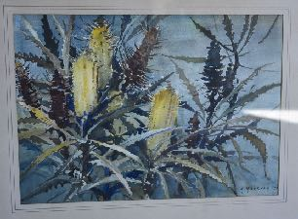
“Banksias”

Artist: Arthur Markham Year Created: Year Acquired:
Location (Street address, location in building, etc):

Location auth. rep. name: Signature:

AUDITORS NOTES:
Quality of artwork (faded, cracked, ripped, etc):

Quality of matt (stained, faded, mouldy, etc):

Quality of frame (Separating, rust, insects, etc):

Action required:

Auditor name: Signature:

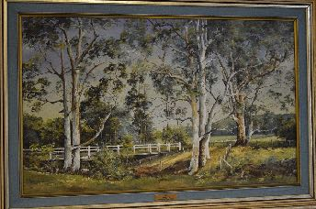
“Bridge at Won Wron”

Artist: Irene Cox Year Created: Year Acquired:
Location (Street address, location in building, etc):

Location auth. rep. name: Signature:

AUDITORS NOTES:
Quality of artwork (faded, cracked, ripped, etc):

Quality of matt (stained, faded, mouldy, etc):

Quality of frame (Separating, rust, insects, etc):

Action required:

Auditor name: Signature:
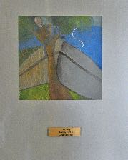
“Contemporary”

Artist: Rodney Forbes Year Created: Year Acquired:
Location (Street address, location in building, etc):

Location auth. rep. name: Signature:

AUDITORS NOTES:
Quality of artwork (faded, cracked, ripped, etc):

Quality of matt (stained, faded, mouldy, etc):

Quality of frame (Separating, rust, insects, etc):

Action required:

Auditor name: Signature:

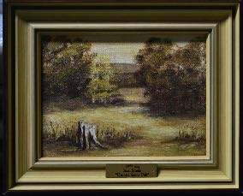
“Country Pair (1)”

Artist: Jean Smale Year Created: Year Acquired:
Location (Street address, location in building, etc):

Location auth. rep. name: Signature:

AUDITORS NOTES:
Quality of artwork (faded, cracked, ripped, etc):

Quality of matt (stained, faded, mouldy, etc):

Quality of frame (Separating, rust, insects, etc):

Action required:

Auditor name: Signature:

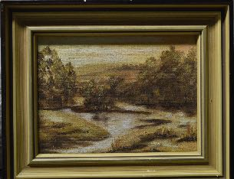
“Country Pair (2)”

Artist: Jean Smale Year Created: Year Acquired:
Location (Street address, location in building, etc):

Location auth. rep. name: Signature:

AUDITORS NOTES:
Quality of artwork (faded, cracked, ripped, etc):

Quality of matt (stained, faded, mouldy, etc):

Quality of frame (Separating, rust, insects, etc):

Action required:

Auditor name: Signature:

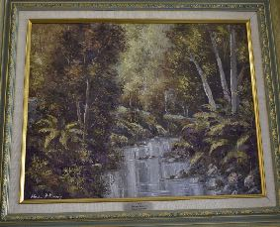
“Creek Hiawatha”

Artist: Theresa J Kennedy Year Created: Year Acquired:
Location (Street address, location in building, etc):

Location auth. rep. name: Signature:

AUDITORS NOTES:
Quality of artwork (faded, cracked, ripped, etc):

Quality of matt (stained, faded, mouldy, etc):

Quality of frame (Separating, rust, insects, etc):

Action required:

Auditor name: Signature:

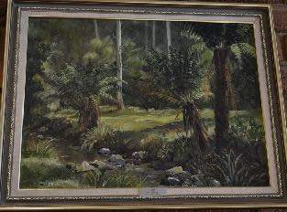
“Creek near Hiawatha”

Artist: Andrea Ramsey Year Created: Year Acquired:
Location (Street address, location in building, etc):

Location auth. rep. name: Signature:

AUDITORS NOTES:
Quality of artwork (faded, cracked, ripped, etc):

Quality of matt (stained, faded, mouldy, etc):

Quality of frame (Separating, rust, insects, etc):

Action required:

Auditor name: Signature:
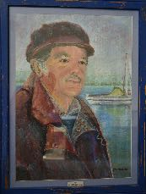
“Da”

Artist: June Christian Year Created: Year Acquired:
Location (Street address, location in building, etc):

Location auth. rep. name: Signature:

AUDITORS NOTES:
Quality of artwork (faded, cracked, ripped, etc):

Quality of matt (stained, faded, mouldy, etc):

Quality of frame (Separating, rust, insects, etc):

Action required:

Auditor name: Signature:

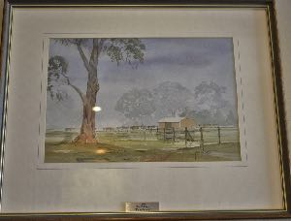
“Dairy Parade”

Artist: Bob Pelchen Year Created: Year Acquired:
Location (Street address, location in building, etc):

Location auth. rep. name: Signature:

AUDITORS NOTES:
Quality of artwork (faded, cracked, ripped, etc):

Quality of matt (stained, faded, mouldy, etc):

Quality of frame (Separating, rust, insects, etc):

Action required:

Auditor name: Signature:

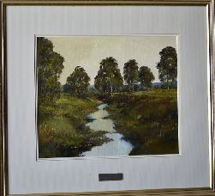
“Dusk”

Artist: Julie Lundgren-Coulter Year Created: Year Acquired:
Location (Street address, location in building, etc):

Location auth. rep. name: Signature:

AUDITORS NOTES:
Quality of artwork (faded, cracked, ripped, etc):

Quality of matt (stained, faded, mouldy, etc):

Quality of frame (Separating, rust, insects, etc):

Action required:

Auditor name: Signature:

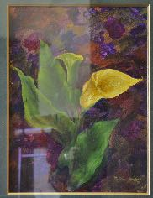
“Flowers”

Artist: Valda Cooper Year Created: Year Acquired:
Location (Street address, location in building, etc):

Location auth. rep. name: Signature:

AUDITORS NOTES:
Quality of artwork (faded, cracked, ripped, etc):

Quality of matt (stained, faded, mouldy, etc):

Quality of frame (Separating, rust, insects, etc):

Action required:

Auditor name: Signature:

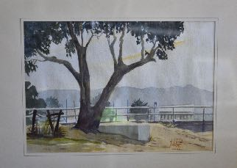
“Footbridge at Lakes Entrance”

Artist: Bob Pelchen Year Created: Year Acquired:
Location (Street address, location in building, etc):

Location auth. rep. name: Signature:

AUDITORS NOTES:
Quality of artwork (faded, cracked, ripped, etc):

Quality of matt (stained, faded, mouldy, etc):

Quality of frame (Separating, rust, insects, etc):

Action required:

Auditor name: Signature:

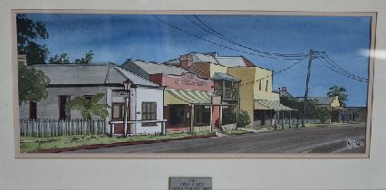
“General Store Port Albert”

Artist: Brian Lee Year Created: Year Acquired:
Location (Street address, location in building, etc):

Location auth. rep. name: Signature:

AUDITORS NOTES:
Quality of artwork (faded, cracked, ripped, etc):

Quality of matt (stained, faded, mouldy, etc):

Quality of frame (Separating, rust, insects, etc):

Action required:

Auditor name: Signature:
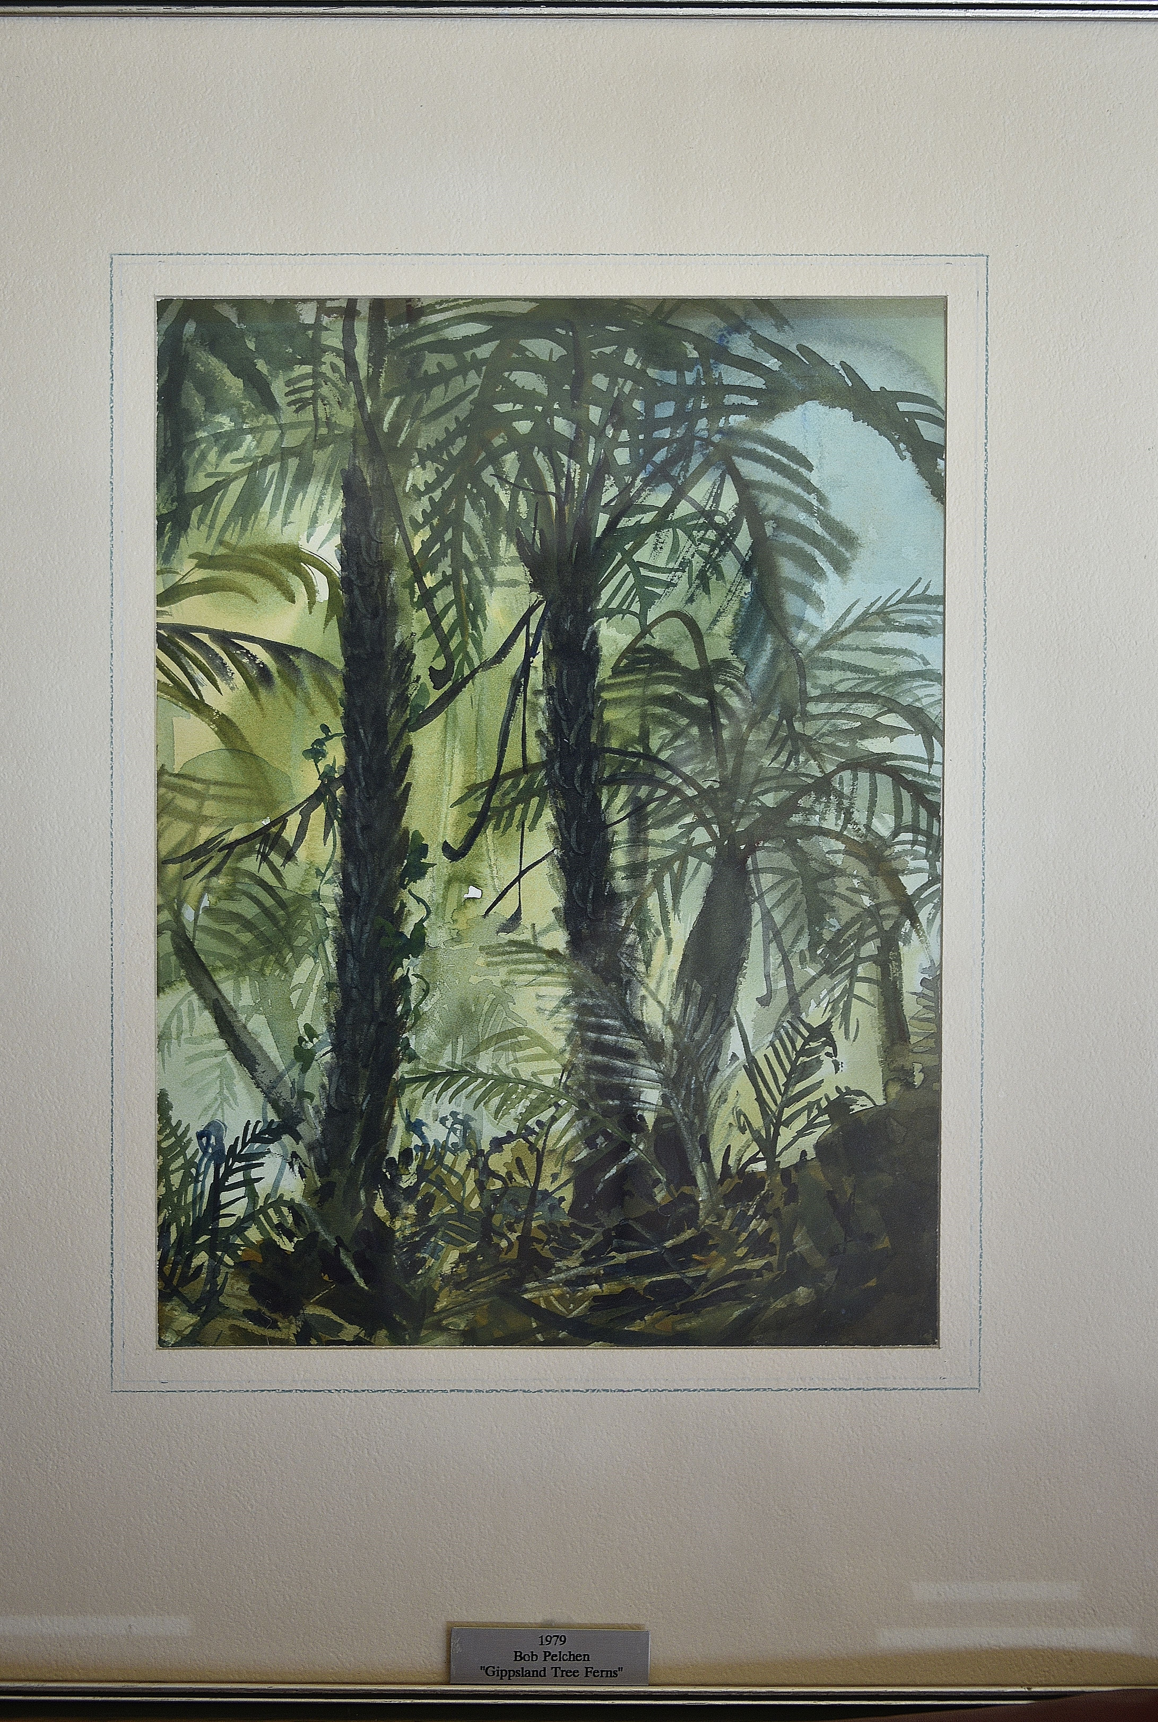
“Gippsland Tree Ferns”

Artist: Bob Pelchen Year Created: Year Acquired:
Location (Street address, location in building, etc):

Location auth. rep. name: Signature:

AUDITORS NOTES:
Quality of artwork (faded, cracked, ripped, etc):

Quality of matt (stained, faded, mouldy, etc):

Quality of frame (Separating, rust, insects, etc):

Action required:

Auditor name: Signature:

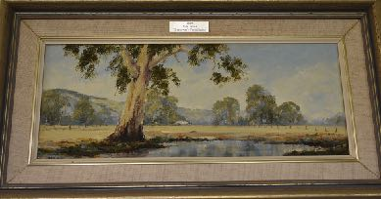
“Greenaway’s Farm Hedley”

Artist: Julie James Year Created: Year Acquired:
Location (Street address, location in building, etc):

Location auth. rep. name: Signature:

AUDITORS NOTES:
Quality of artwork (faded, cracked, ripped, etc):

Quality of matt (stained, faded, mouldy, etc):

Quality of frame (Separating, rust, insects, etc):

Action required:

Auditor name: Signature:

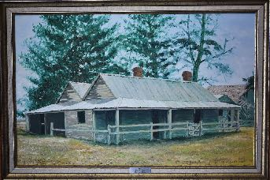
“Hawthorn Bank”
Artist: Edna Gooding Year Created: Year Acquired:
Location (Street address, location in building, etc):

Location auth. rep. name: Signature:

AUDITORS NOTES:
Quality of artwork (faded, cracked, ripped, etc):

Quality of matt (stained, faded, mouldy, etc):

Quality of frame (Separating, rust, insects, etc):

Action required:

Auditor name: Signature:

“Hiawatha”
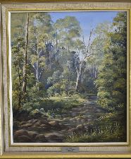

Artist: Jeanette Jackson Year Created: Year Acquired:
Location (Street address, location in building, etc):

Location auth. rep. name: Signature:

AUDITORS NOTES:
Quality of artwork (faded, cracked, ripped, etc):

Quality of matt (stained, faded, mouldy, etc):

Quality of frame (Separating, rust, insects, etc):

Action required:

Auditor name: Signature:

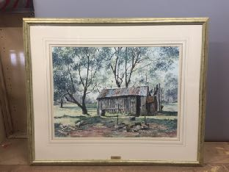
“High Country Hut”

Artist: Jan Long Year Created: Year Acquired:
Location (Street address, location in building, etc):

Location auth. rep. name: Signature:

AUDITORS NOTES:
Quality of artwork (faded, cracked, ripped, etc):

Quality of matt (stained, faded, mouldy, etc):

Quality of frame (Separating, rust, insects, etc):

Action required:

Auditor name: Signature:

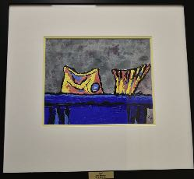
“In a Fish Box”

Artist: Kim Pederson Year Created: Year Acquired:
Location (Street address, location in building, etc):

Location auth. rep. name: Signature:

AUDITORS NOTES:
Quality of artwork (faded, cracked, ripped, etc):

Quality of matt (stained, faded, mouldy, etc):

Quality of frame (Separating, rust, insects, etc):

Action required:

Auditor name: Signature:
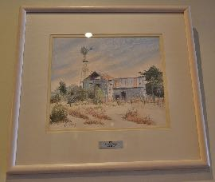
“Jack River”

Artist: Yvonne Voysey Year Created: Year Acquired:
Location (Street address, location in building, etc):

Location auth. rep. name: Signature:

AUDITORS NOTES:
Quality of artwork (faded, cracked, ripped, etc):

Quality of matt (stained, faded, mouldy, etc):

Quality of frame (Separating, rust, insects, etc):

Action required:

Auditor name: Signature:

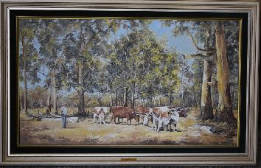
“Joe and the Bullocks”

Artist: Irene Cox Year Created: Year Acquired:
Location (Street address, location in building, etc):

Location auth. rep. name: Signature:

AUDITORS NOTES:
Quality of artwork (faded, cracked, ripped, etc):

Quality of matt (stained, faded, mouldy, etc):

Quality of frame (Separating, rust, insects, etc):

Action required:

Auditor name: Signature:

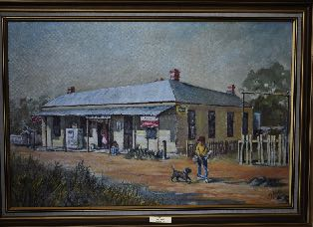
“Longford Pub”

Artist: Marj Miller Year Created: Year Acquired:
Location (Street address, location in building, etc):

Location auth. rep. name: Signature:

AUDITORS NOTES:
Quality of artwork (faded, cracked, ripped, etc):

Quality of matt (stained, faded, mouldy, etc):

Quality of frame (Separating, rust, insects, etc):

Action required:

Auditor name: Signature:

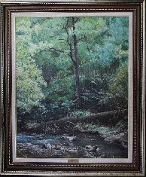
“Middle Creek”

Artist: Marilyn Close Year Created: Year Acquired:
Location (Street address, location in building, etc):

Location auth. rep. name: Signature:

AUDITORS NOTES:
Quality of artwork (faded, cracked, ripped, etc):

Quality of matt (stained, faded, mouldy, etc):

Quality of frame (Separating, rust, insects, etc):

Action required:

Auditor name: Signature:

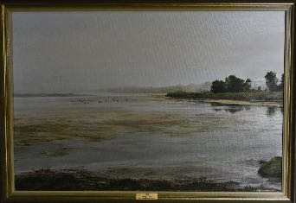
“Misty Backwaters Seaspray”
Artist: Marilyn Close Year Created: Year Acquired:
Location (Street address, location in building, etc):

Location auth. rep. name: Signature:

AUDITORS NOTES:
Quality of artwork (faded, cracked, ripped, etc):

Quality of matt (stained, faded, mouldy, etc):

Quality of frame (Separating, rust, insects, etc):

Action required:

Auditor name: Signature:

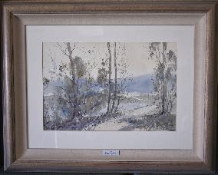
“Misty Morning Gippsland”

Artist: Julie Lundgren-Coulter Year Created: Year Acquired:
Location (Street address, location in building, etc):

Location auth. rep. name: Signature:

AUDITORS NOTES:
Quality of artwork (faded, cracked, ripped, etc):

Quality of matt (stained, faded, mouldy, etc):

Quality of frame (Separating, rust, insects, etc):

Action required:

Auditor name: Signature:

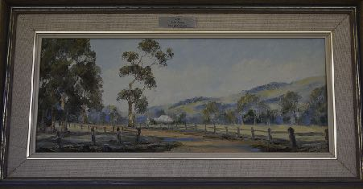
“Morgans Road”
Artist: Julie James Year Created: Year Acquired:
Location (Street address, location in building, etc):

Location auth. rep. name: Signature:

AUDITORS NOTES:
Quality of artwork (faded, cracked, ripped, etc):

Quality of matt (stained, faded, mouldy, etc):

Quality of frame (Separating, rust, insects, etc):

Action required:

Auditor name: Signature:

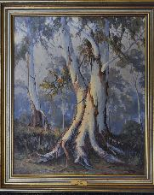
“Morning Carrajung”

Artist: Barry Alford Year Created: Year Acquired:
Location (Street address, location in building, etc):

Location auth. rep. name: Signature:

AUDITORS NOTES:
Quality of artwork (faded, cracked, ripped, etc):

Quality of matt (stained, faded, mouldy, etc):

Quality of frame (Separating, rust, insects, etc):

Action required:

Auditor name: Signature:

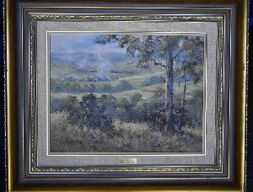
“Morning Light Millgrove”

Artist: Pauline Steward Year Created: Year Acquired:
Location (Street address, location in building, etc):

Location auth. rep. name: Signature:

AUDITORS NOTES:
Quality of artwork (faded, cracked, ripped, etc):

Quality of matt (stained, faded, mouldy, etc):

Quality of frame (Separating, rust, insects, etc):

Action required:

Auditor name: Signature:

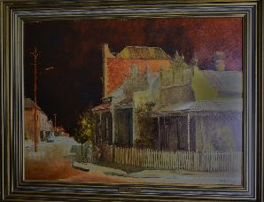
“New Bike”

Artist: Warren Curry Year Created: Year Acquired:
Location (Street address, location in building, etc):

Location auth. rep. name: Signature:

AUDITORS NOTES:
Quality of artwork (faded, cracked, ripped, etc):

Quality of matt (stained, faded, mouldy, etc):

Quality of frame (Separating, rust, insects, etc):

Action required:

Auditor name: Signature:

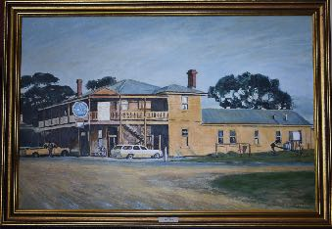
“Port Albert Pub”

Artist: Edna Gooding Year Created: Year Acquired:
Location (Street address, location in building, etc):

Location auth. rep. name: Signature:

AUDITORS NOTES:
Quality of artwork (faded, cracked, ripped, etc):

Quality of matt (stained, faded, mouldy, etc):

Quality of frame (Separating, rust, insects, etc):

Action required:

Auditor name: Signature:

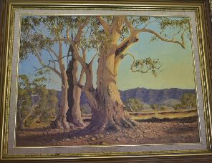
“Price Creek S.A.”

Artist: Barry Alford Year Created: Year Acquired:
Location (Street address, location in building, etc):

Location auth. rep. name: Signature:

AUDITORS NOTES:
Quality of artwork (faded, cracked, ripped, etc):

Quality of matt (stained, faded, mouldy, etc):

Quality of frame (Separating, rust, insects, etc):

Action required:

Auditor name: Signature:

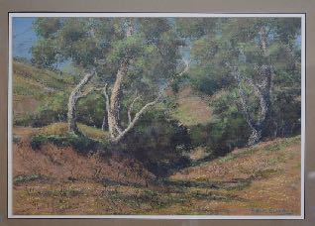
“Red Gold Country”

Artist: Edna Gooding Year Created: Year Acquired:
Location (Street address, location in building, etc):

Location auth. rep. name: Signature:

AUDITORS NOTES:
Quality of artwork (faded, cracked, ripped, etc):

Quality of matt (stained, faded, mouldy, etc):

Quality of frame (Separating, rust, insects, etc):

Action required:

Auditor name: Signature:

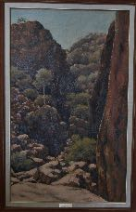
“Red Rocks Blue Sky”

Artist: Edna Gooding Year Created: Year Acquired:
Location (Street address, location in building, etc):

Location auth. rep. name: Signature:

AUDITORS NOTES:
Quality of artwork (faded, cracked, ripped, etc):

Quality of matt (stained, faded, mouldy, etc):

Quality of frame (Separating, rust, insects, etc):

Action required:

Auditor name: Signature:

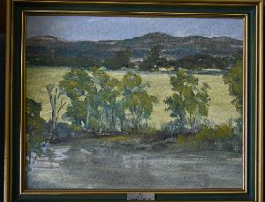
“Reflections on the Albert”

Artist: Alan Wood Year Created: Year Acquired:
Location (Street address, location in building, etc):

Location auth. rep. name: Signature:

AUDITORS NOTES:
Quality of artwork (faded, cracked, ripped, etc):

Quality of matt (stained, faded, mouldy, etc):

Quality of frame (Separating, rust, insects, etc):

Action required:

Auditor name: Signature:

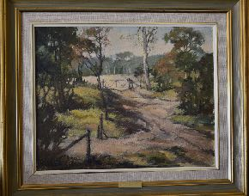
“Road to the Back Paddock”

Artist: Nan Bretel Year Created: Year Acquired:
Location (Street address, location in building, etc):

Location auth. rep. name: Signature:

AUDITORS NOTES:
Quality of artwork (faded, cracked, ripped, etc):

Quality of matt (stained, faded, mouldy, etc):

Quality of frame (Separating, rust, insects, etc):

Action required:

Auditor name: Signature:

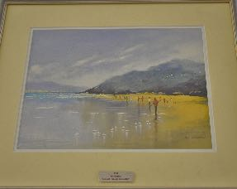
“Sea Mist Wilson’s Prom”

Artist: Iris Burston Year Created: Year Acquired:
Location (Street address, location in building, etc):

Location auth. rep. name: Signature:

AUDITORS NOTES:
Quality of artwork (faded, cracked, ripped, etc):

Quality of matt (stained, faded, mouldy, etc):

Quality of frame (Separating, rust, insects, etc):

Action required:

Auditor name: Signature:

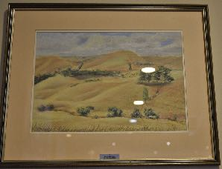
“South Gippsland Hills”

Artist: Jennifer Breeden Year Created: Year Acquired:
Location (Street address, location in building, etc):

Location auth. rep. name: Signature:

AUDITORS NOTES:
Quality of artwork (faded, cracked, ripped, etc):

Quality of matt (stained, faded, mouldy, etc):

Quality of frame (Separating, rust, insects, etc):

Action required:

Auditor name: Signature:

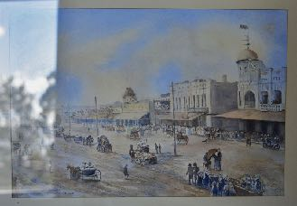
“Street Parade”

Artist: June Cook Year Created: Year Acquired:
Location (Street address, location in building, etc):

Location auth. rep. name: Signature:

AUDITORS NOTES:
Quality of artwork (faded, cracked, ripped, etc):

Quality of matt (stained, faded, mouldy, etc):

Quality of frame (Separating, rust, insects, etc):

Action required:

Auditor name: Signature:

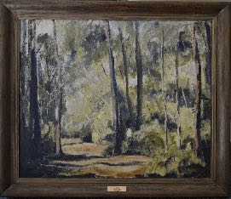
“Sunlight”

Artist: Judith Walsh Year Created: Year Acquired:
Location (Street address, location in building, etc):

Location auth. rep. name: Signature:

AUDITORS NOTES:
Quality of artwork (faded, cracked, ripped, etc):

Quality of matt (stained, faded, mouldy, etc):

Quality of frame (Separating, rust, insects, etc):

Action required:

Auditor name: Signature:

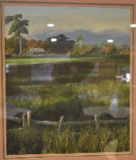
“Sunrise Hedley”

Artist: Julie James Year Created: Year Acquired:
Location (Street address, location in building, etc):

Location auth. rep. name: Signature:

AUDITORS NOTES:
Quality of artwork (faded, cracked, ripped, etc):

Quality of matt (stained, faded, mouldy, etc):

Quality of frame (Separating, rust, insects, etc):

Action required:

Auditor name: Signature:

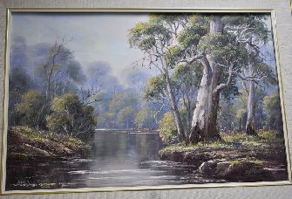
“Tambo River”

Artist: Audrey Taylor Year Created: Year Acquired:
Location (Street address, location in building, etc):

Location auth. rep. name: Signature:

AUDITORS NOTES:
Quality of artwork (faded, cracked, ripped, etc):

Quality of matt (stained, faded, mouldy, etc):

Quality of frame (Separating, rust, insects, etc):

Action required:

Auditor name: Signature:

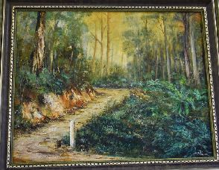
“Tarra Valley Road”

Artist: Betty Pattinson Year Created: Year Acquired:
Location (Street address, location in building, etc):

Location auth. rep. name: Signature:

AUDITORS NOTES:
Quality of artwork (faded, cracked, ripped, etc):

Quality of matt (stained, faded, mouldy, etc):

Quality of frame (Separating, rust, insects, etc):

Action required:

Auditor name: Signature:

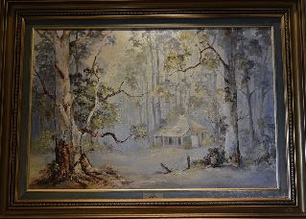
“The Clearing”

Artist: Irene Cox Year Created: Year Acquired:
Location (Street address, location in building, etc):

Location auth. rep. name: Signature:

AUDITORS NOTES:
Quality of artwork (faded, cracked, ripped, etc):

Quality of matt (stained, faded, mouldy, etc):

Quality of frame (Separating, rust, insects, etc):

Action required:

Auditor name: Signature:

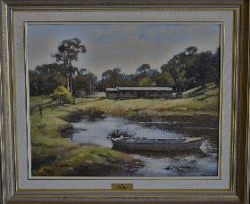
“The Farm Boat”

Artist: Nan Bretel Year Created: Year Acquired:
Location (Street address, location in building, etc):

Location auth. rep. name: Signature:

AUDITORS NOTES:
Quality of artwork (faded, cracked, ripped, etc):

Quality of matt (stained, faded, mouldy, etc):

Quality of frame (Separating, rust, insects, etc):

Action required:

Auditor name: Signature:

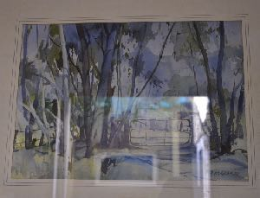
“The Gate”

Artist: Arthur Markham Year Created: Year Acquired:
Location (Street address, location in building, etc):

Location auth. rep. name: Signature:

AUDITORS NOTES:
Quality of artwork (faded, cracked, ripped, etc):

Quality of matt (stained, faded, mouldy, etc):

Quality of frame (Separating, rust, insects, etc):

Action required:

Auditor name: Signature:

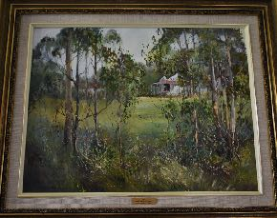
“Through The Trees”

Artist: Julie Lundgren-Coulter Year Created: Year Acquired:
Location (Street address, location in building, etc):

Location auth. rep. name: Signature:

AUDITORS NOTES:
Quality of artwork (faded, cracked, ripped, etc):

Quality of matt (stained, faded, mouldy, etc):

Quality of frame (Separating, rust, insects, etc):

Action required:

Auditor name: Signature:

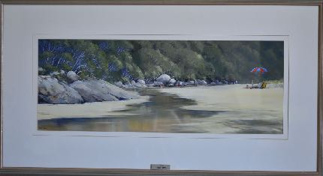
“Tidal River”

Artist: Julie James Year Created: Year Acquired:
Location (Street address, location in building, etc):

Location auth. rep. name: Signature:

AUDITORS NOTES:
Quality of artwork (faded, cracked, ripped, etc):

Quality of matt (stained, faded, mouldy, etc):

Quality of frame (Separating, rust, insects, etc):

Action required:

Auditor name: Signature:

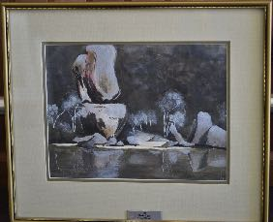
“Tidal River”

Artist: Phyllis Egan Year Created: Year Acquired:
Location (Street address, location in building, etc):

Location auth. rep. name: Signature:

AUDITORS NOTES:
Quality of artwork (faded, cracked, ripped, etc):

Quality of matt (stained, faded, mouldy, etc):

Quality of frame (Separating, rust, insects, etc):

Action required:

Auditor name: Signature:

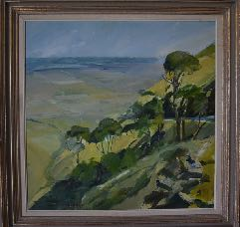
“Toora Landscape”

Artist: Peter Wegner Year Created: Year Acquired:
Location (Street address, location in building, etc):

Location auth. rep. name: Signature:

AUDITORS NOTES:
Quality of artwork (faded, cracked, ripped, etc):

Quality of matt (stained, faded, mouldy, etc):

Quality of frame (Separating, rust, insects, etc):

Action required:

Auditor name: Signature:

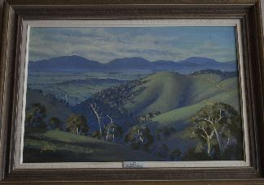
“Towards Gormandale”

Artist: Barry Alford Year Created: Year Acquired:
Location (Street address, location in building, etc):

Location auth. rep. name: Signature:

AUDITORS NOTES:
Quality of artwork (faded, cracked, ripped, etc):

Quality of matt (stained, faded, mouldy, etc):

Quality of frame (Separating, rust, insects, etc):

Action required:

Auditor name: Signature:

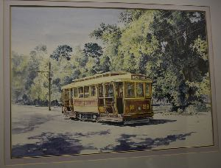
“Tram Rides”

Artist: Jan Long Year Created: Year Acquired:
Location (Street address, location in building, etc):

Location auth. rep. name: Signature:

AUDITORS NOTES:
Quality of artwork (faded, cracked, ripped, etc):

Quality of matt (stained, faded, mouldy, etc):

Quality of frame (Separating, rust, insects, etc):

Action required:

Auditor name: Signature:

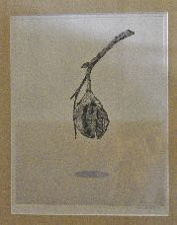
“Untitled”

Artist: Karen Gregson Year Created: Year Acquired:
Location (Street address, location in building, etc):

Location auth. rep. name: Signature:

AUDITORS NOTES:
Quality of artwork (faded, cracked, ripped, etc):

Quality of matt (stained, faded, mouldy, etc):

Quality of frame (Separating, rust, insects, etc):

Action required:

Auditor name: Signature:

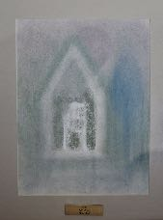
“Untitled”

Artist: Sue Nicol Year Created: Year Acquired:
Location (Street address, location in building, etc):

Location auth. rep. name: Signature:

AUDITORS NOTES:
Quality of artwork (faded, cracked, ripped, etc):

Quality of matt (stained, faded, mouldy, etc):

Quality of frame (Separating, rust, insects, etc):

Action required:

Auditor name: Signature:

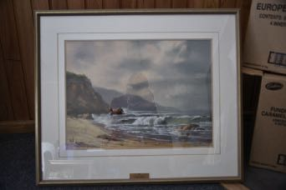
“Victorian Coastline”

Artist: Lorraine Davies Year Created: Year Acquired:
Location (Street address, location in building, etc):

Location auth. rep. name: Signature:

AUDITORS NOTES:
Quality of artwork (faded, cracked, ripped, etc):

Quality of matt (stained, faded, mouldy, etc):

Quality of frame (Separating, rust, insects, etc):

Action required:

Auditor name: Signature:

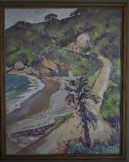
“Walkerville”

Artist: Sue Jarvis Year Created: Year Acquired:
Location (Street address, location in building, etc):

Location auth. rep. name: Signature:

AUDITORS NOTES:
Quality of artwork (faded, cracked, ripped, etc):

Quality of matt (stained, faded, mouldy, etc):

Quality of frame (Separating, rust, insects, etc):

Action required:

Auditor name: Signature:

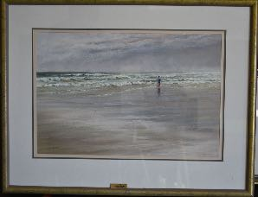
“Waratah Bay”

Artist: Lorraine Wigraft Year Created: Year Acquired:
Location (Street address, location in building, etc):

Location auth. rep. name: Signature:

AUDITORS NOTES:
Quality of artwork (faded, cracked, ripped, etc):

Quality of matt (stained, faded, mouldy, etc):

Quality of frame (Separating, rust, insects, etc):

Action required:

Auditor name: Signature:

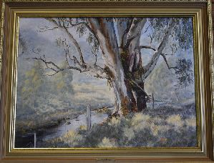
“Widowmaker Gum Won Wron”

Artist: Lorraine Mumford Year Created: Year Acquired:
Location (Street address, location in building, etc):

Location auth. rep. name: Signature:

AUDITORS NOTES:
Quality of artwork (faded, cracked, ripped, etc):

Quality of matt (stained, faded, mouldy, etc):

Quality of frame (Separating, rust, insects, etc):

Action required:

Auditor name: Signature:

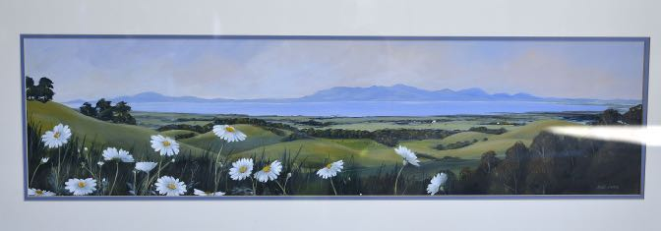
“Wilson’s Promontory”

Artist: Julie James Year Created: Year Acquired:
Location (Street address, location in building, etc):

Location auth. rep. name: Signature:

AUDITORS NOTES:
Quality of artwork (faded, cracked, ripped, etc):

Quality of matt (stained, faded, mouldy, etc):

Quality of frame (Separating, rust, insects, etc):

Action required:

Auditor name: Signature:

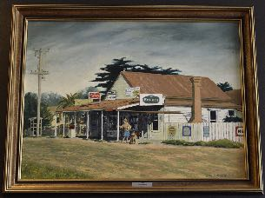
“Woodside Store”

Artist: Edna Gooding Year Created: Year Acquired:
Location (Street address, location in building, etc):

Location auth. rep. name: Signature:

AUDITORS NOTES:
Quality of artwork (faded, cracked, ripped, etc):

Quality of matt (stained, faded, mouldy, etc):

Quality of frame (Separating, rust, insects, etc):

Action required:

Auditor name: Signature:

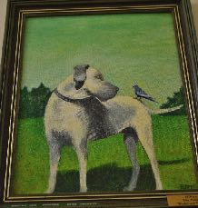
“Woofer and Tweeter”

Artist: Rita Tuckett Year Created: Year Acquired:
Location (Street address, location in building, etc):

Location auth. rep. name: Signature:

AUDITORS NOTES:
Quality of artwork (faded, cracked, ripped, etc):

Quality of matt (stained, faded, mouldy, etc):

Quality of frame (Separating, rust, insects, etc):

Action required:

Auditor name: Signature:

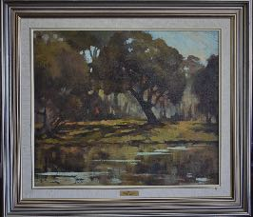
“Yarra River”

Artist: Barbara McManus Year Created: Year Acquired:
Location (Street address, location in building, etc):

Location auth. rep. name: Signature:

AUDITORS NOTES:
Quality of artwork (faded, cracked, ripped, etc):

Quality of matt (stained, faded, mouldy, etc):

Quality of frame (Separating, rust, insects, etc):

Action required:

Auditor name: Signature:

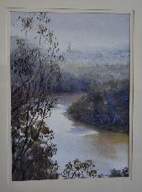
“Yarra River Studley Park”

Artist: Jeannine Desailly Year Created: Year Acquired:
Location (Street address, location in building, etc):

Location auth. rep. name: Signature:

AUDITORS NOTES:
Quality of artwork (faded, cracked, ripped, etc):

Quality of matt (stained, faded, mouldy, etc):

Quality of frame (Separating, rust, insects, etc):

Action required:

Auditor name: Signature:

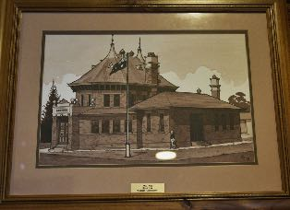
“Yarram Courthouse”

Artist: Brian Lee Year Created: Year Acquired:
Location (Street address, location in building, etc):

Location auth. rep. name: Signature:

AUDITORS NOTES:
Quality of artwork (faded, cracked, ripped, etc):

Quality of matt (stained, faded, mouldy, etc):

Quality of frame (Separating, rust, insects, etc):

Action required:

Auditor name: Signature:

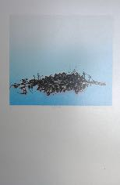
“Untitled”
SADLY
DAMAGED BEYOND REPAIR

Artist: Karen Gregson Year Created: Year Acquired:
Location (Street address, location in building, etc):

Apex Club Rooms

Location auth. rep. name: Signature:

AUDITORS NOTES:
Quality of artwork (faded, cracked, ripped, etc):

Quality of matt (stained, faded, mouldy, etc):

Mould growth on Mattboard.

Quality of frame (Separating, rust, insects, etc):

Action required:

This artwork is no longer suitable for public viewing in its physical state.

Check to see if it can be photographed to preserve artistic value and for online exhibition use.

Auditor name: Signature:

